EXP NO 25. Database as a Service (DaaS) create and configure a new VM Image in any Public Cloud
Service Provider using Azure.

AIM: DATABASE AS A SERVICE (DAAS) CREATE AND CONFIGURE A NEW VM IMAGE IN ANY PUBLIC CLOUD SERVICE PROVIDER USING AZURE
PROCEDURE:
STEP1: GOTO AZURE AND GOTO SQLDATABASE.
STEP 02: Now Create a Sql Databse
STEP3: SELECT THE RESOURCE GROUPAND ENTER THE SERVERNAMETHATAPPLICABLE.
STEP4: IN NETWORKING SELECT ALLOW AZURE SERVICES AND
RESOURCES TO ACCESS THIS SERVER.
STEP5: IN ADDITIONAL SETTINGS SELECT SAMPLE.
STEP6:AND THE SQL DATABASE IS DEPLOYED
TEP7: NOW GOTO QUERY EDITOR.
STEP8:NOWAGAIN LOGIN TO THE SQLDATADATABASE
STEP9: OUR TABLES WILL SHOWN AND TYPE THE QUERY TO EXCUTED.

IMPLEMENTATION:
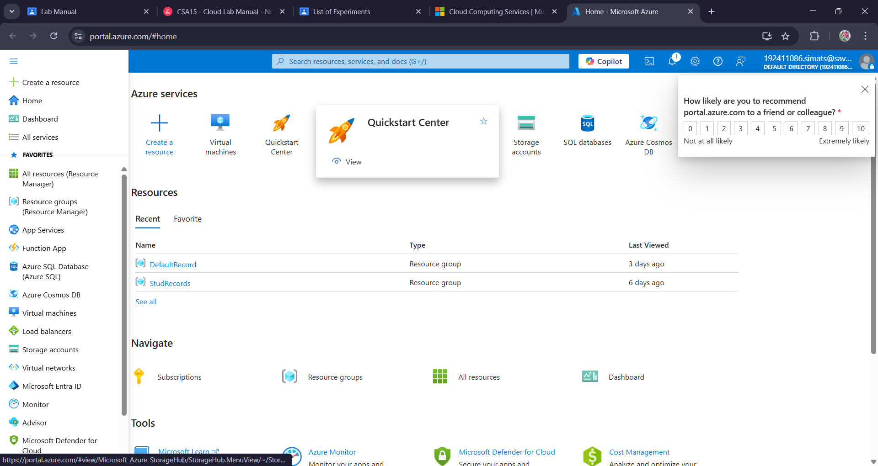

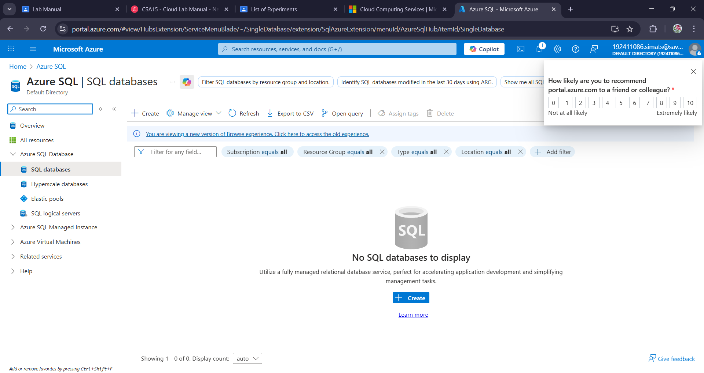
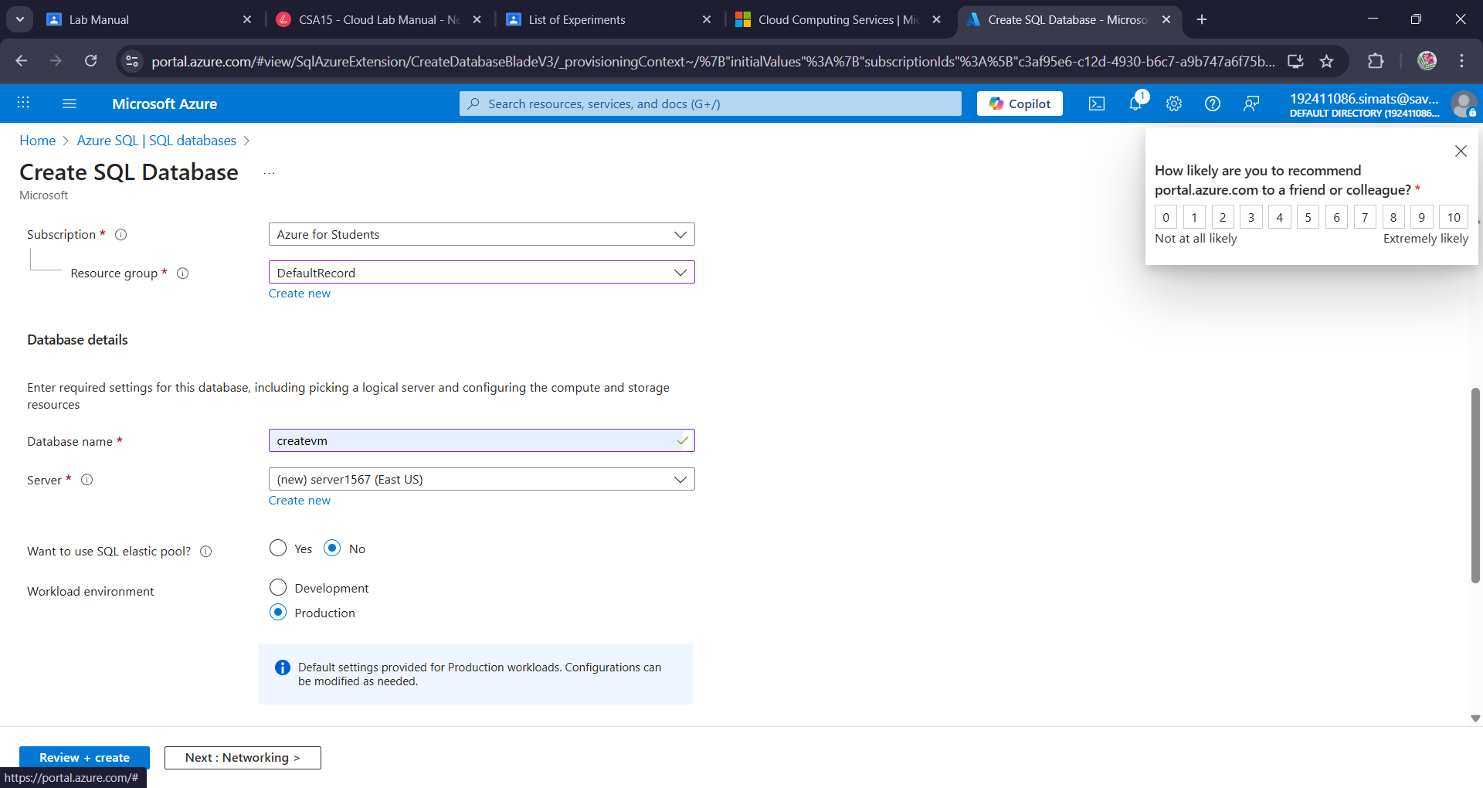

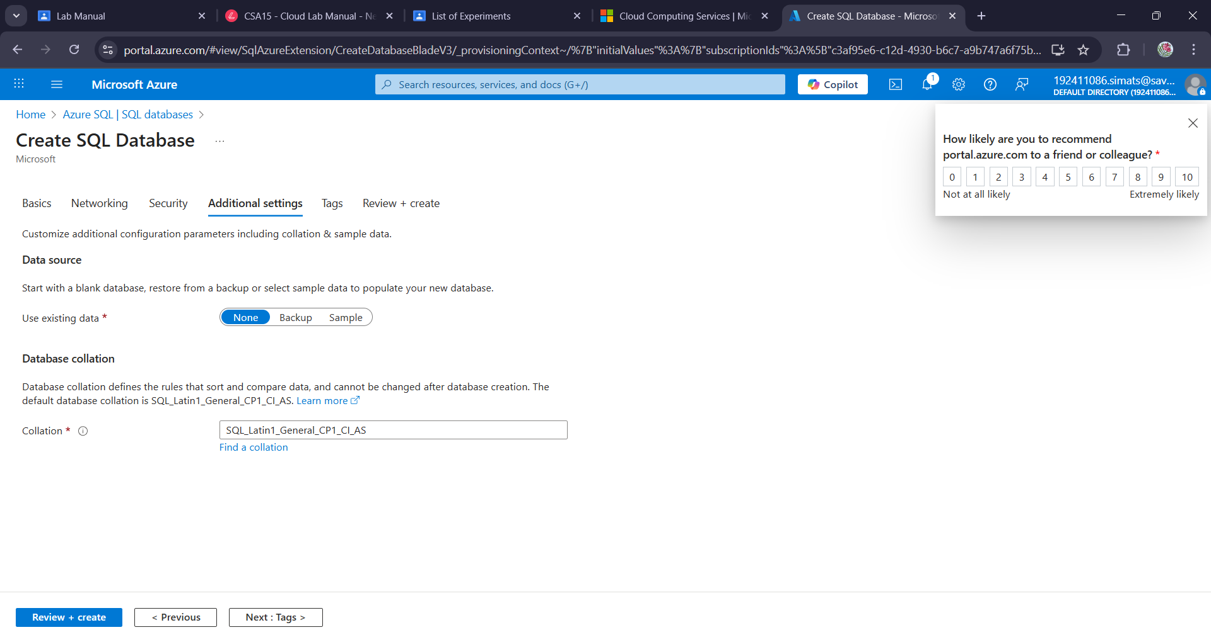

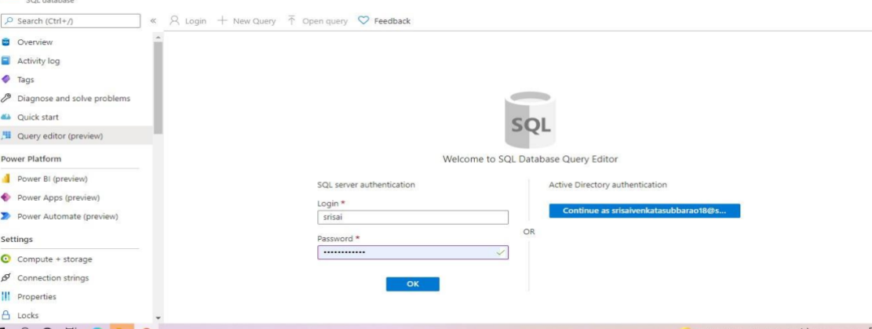

Result:
A service (daas) create and configure a new vm image in any public cloud service provider using azure has been created.

